**Forestry.io Guide**

Login at <https://app.forestry.io/login>

The CMS homepage should look like this. Edit your site from the sidebar. There is one sidebar item per page on the website.

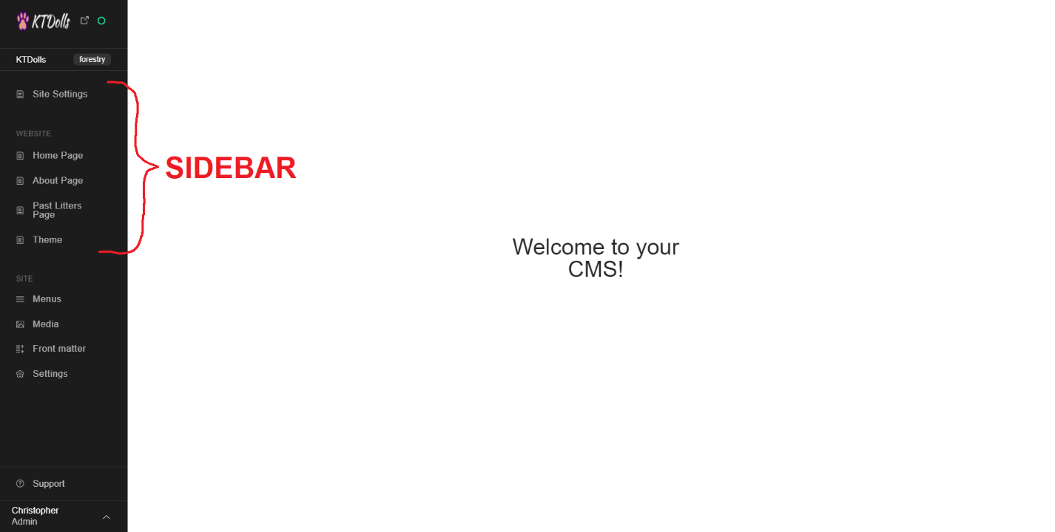

Let’s edit the About page. The first thing you should do is click the preview button in the top right so you can view the changes you have made before publishing them. If it has not automatically started the preview server, it will begin to do so. It will take a minute or two to build the preview server, but that only needs to be done once.

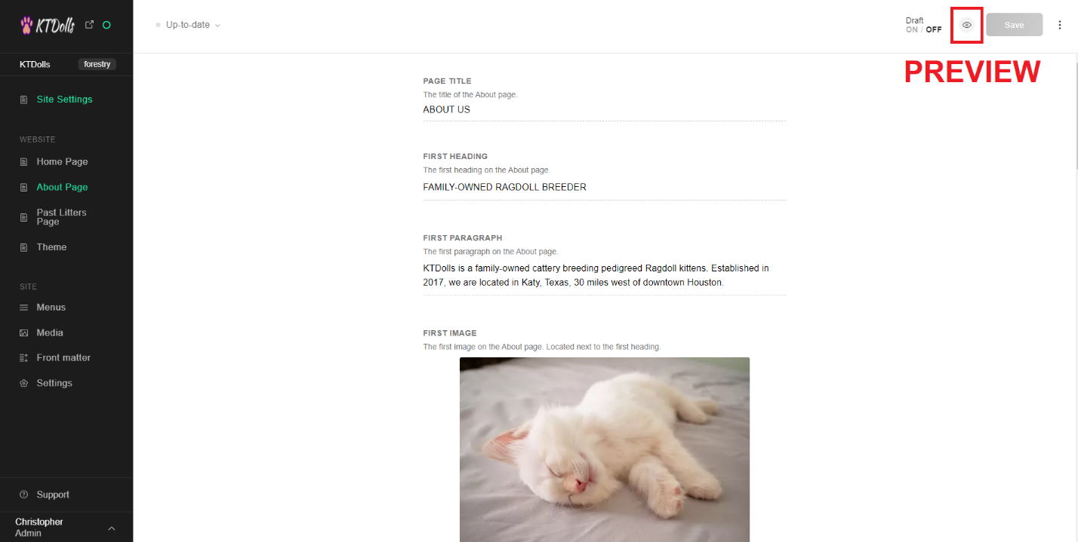

Click the preview button, and a new tab will open with a preview of the web page.

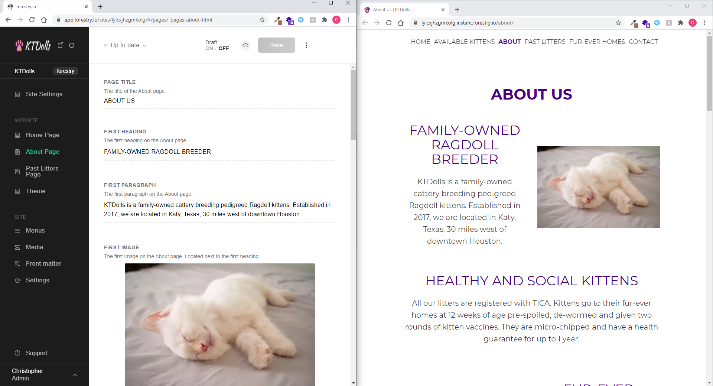

Now let’s edit our web page. Let’s change our location to Dallas and change the first image on the page.

We edit our first paragraph.

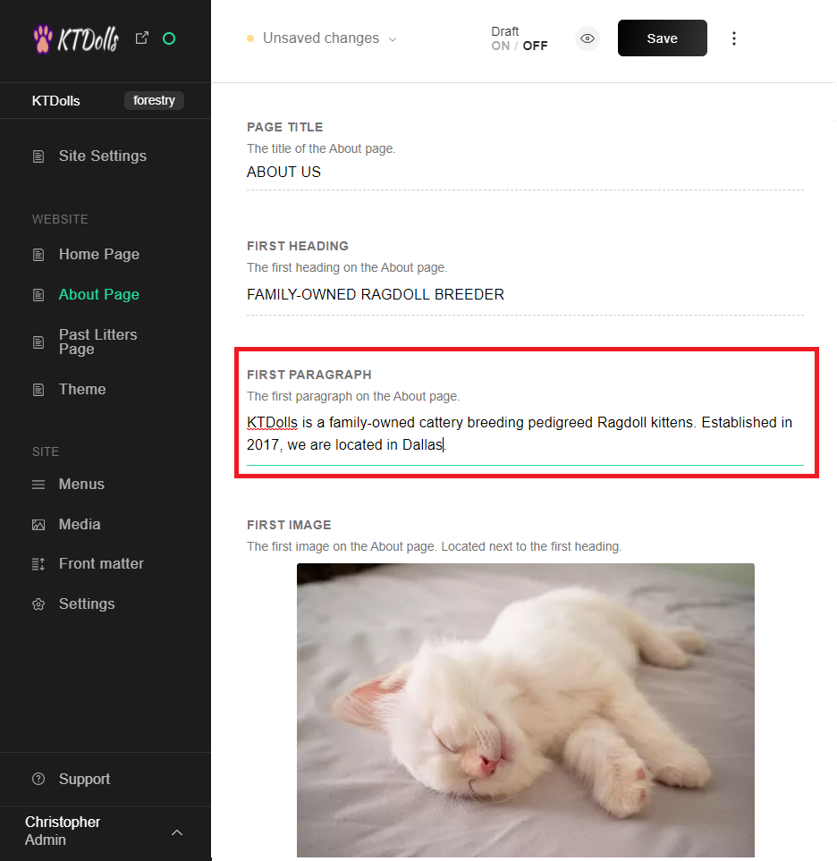

To change the image, hover over the image and click “REPLACE”. This will bring up the media manager.

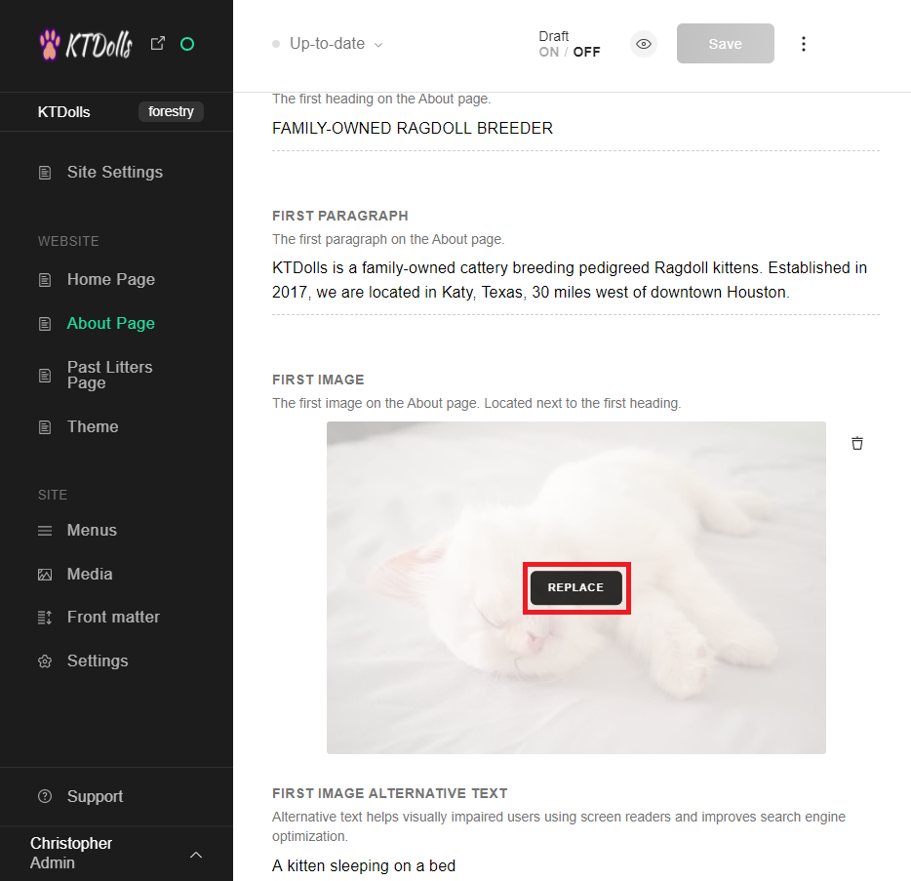

Click “UPLOAD” in the top right to upload your image. Your file explorer will open. Select your image and you will have successfully replaced the previous image.

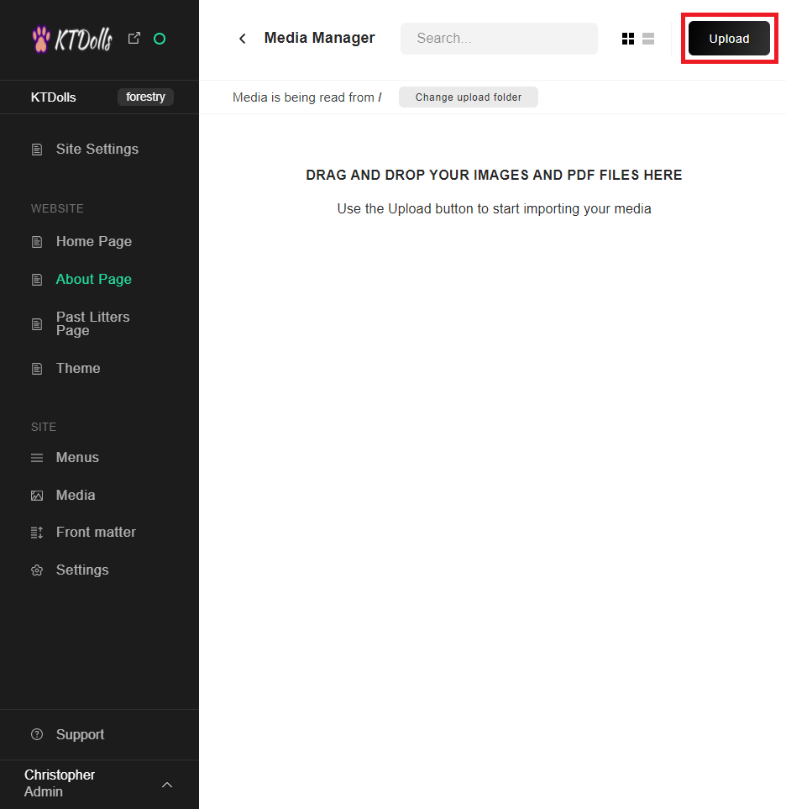

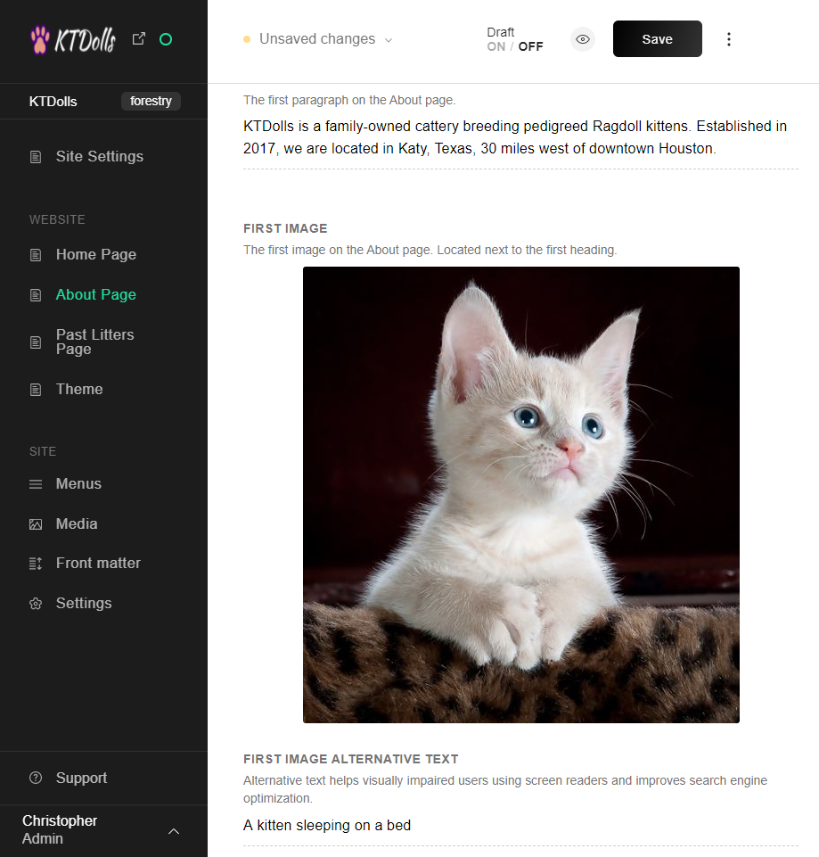

If you have already uploaded the image you would like to use to the media manager, it will show up there after clicking replace. Simply click on the image and then the insert button in the bottom left.

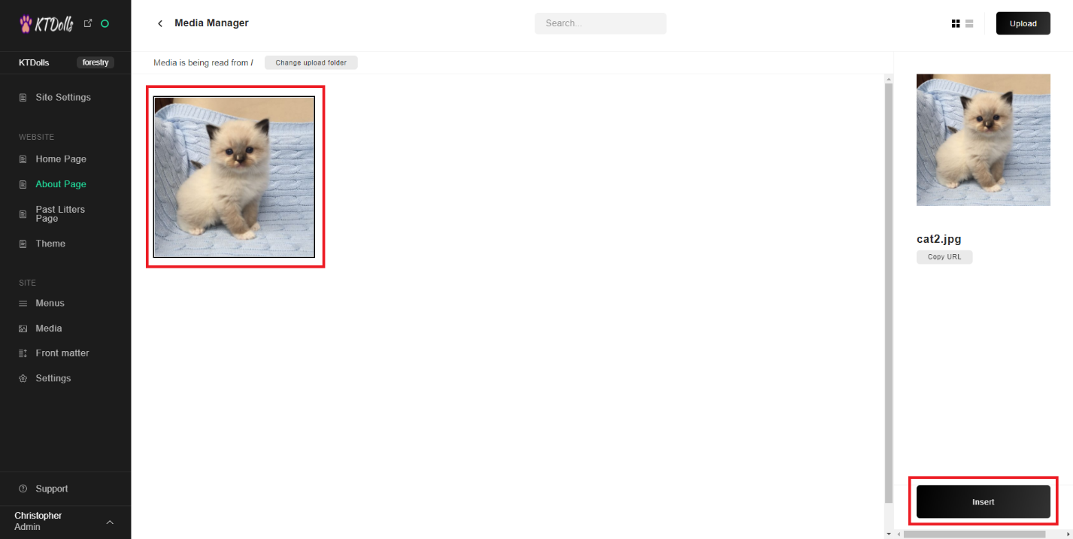

Now you should preview your changes to make sure they are right before publishing them. Click the preview button.

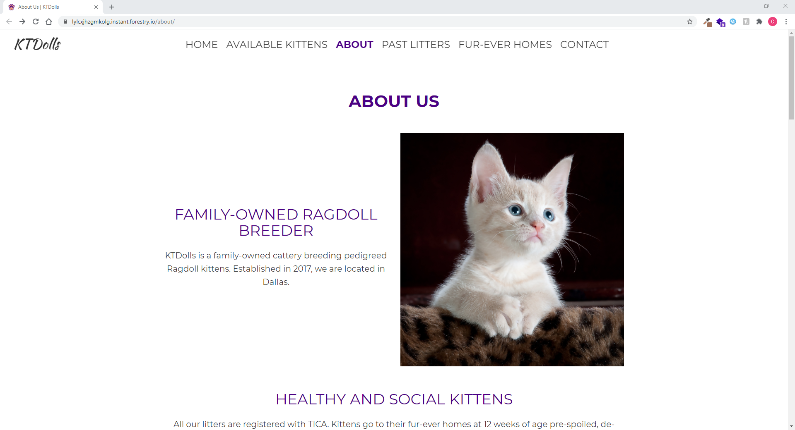

And everything looks great. You can now click “SAVE” in the top right. Doing so will publish your changes to the actual website.

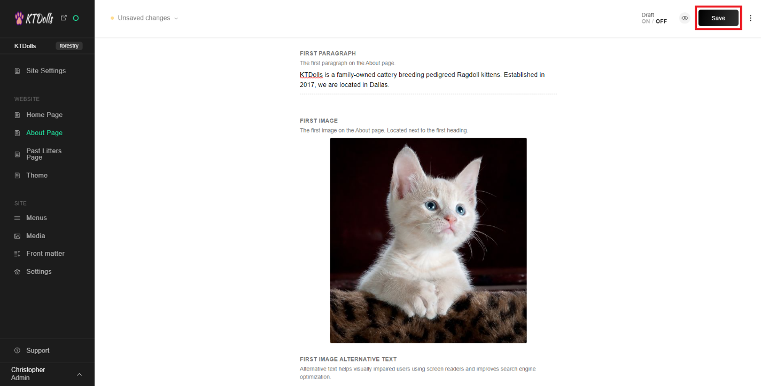

**Important Notes**

Do not drag and drop the image you want to use from the file explorer to the media manager. Doing so will place the image at the start of the web page as shown.

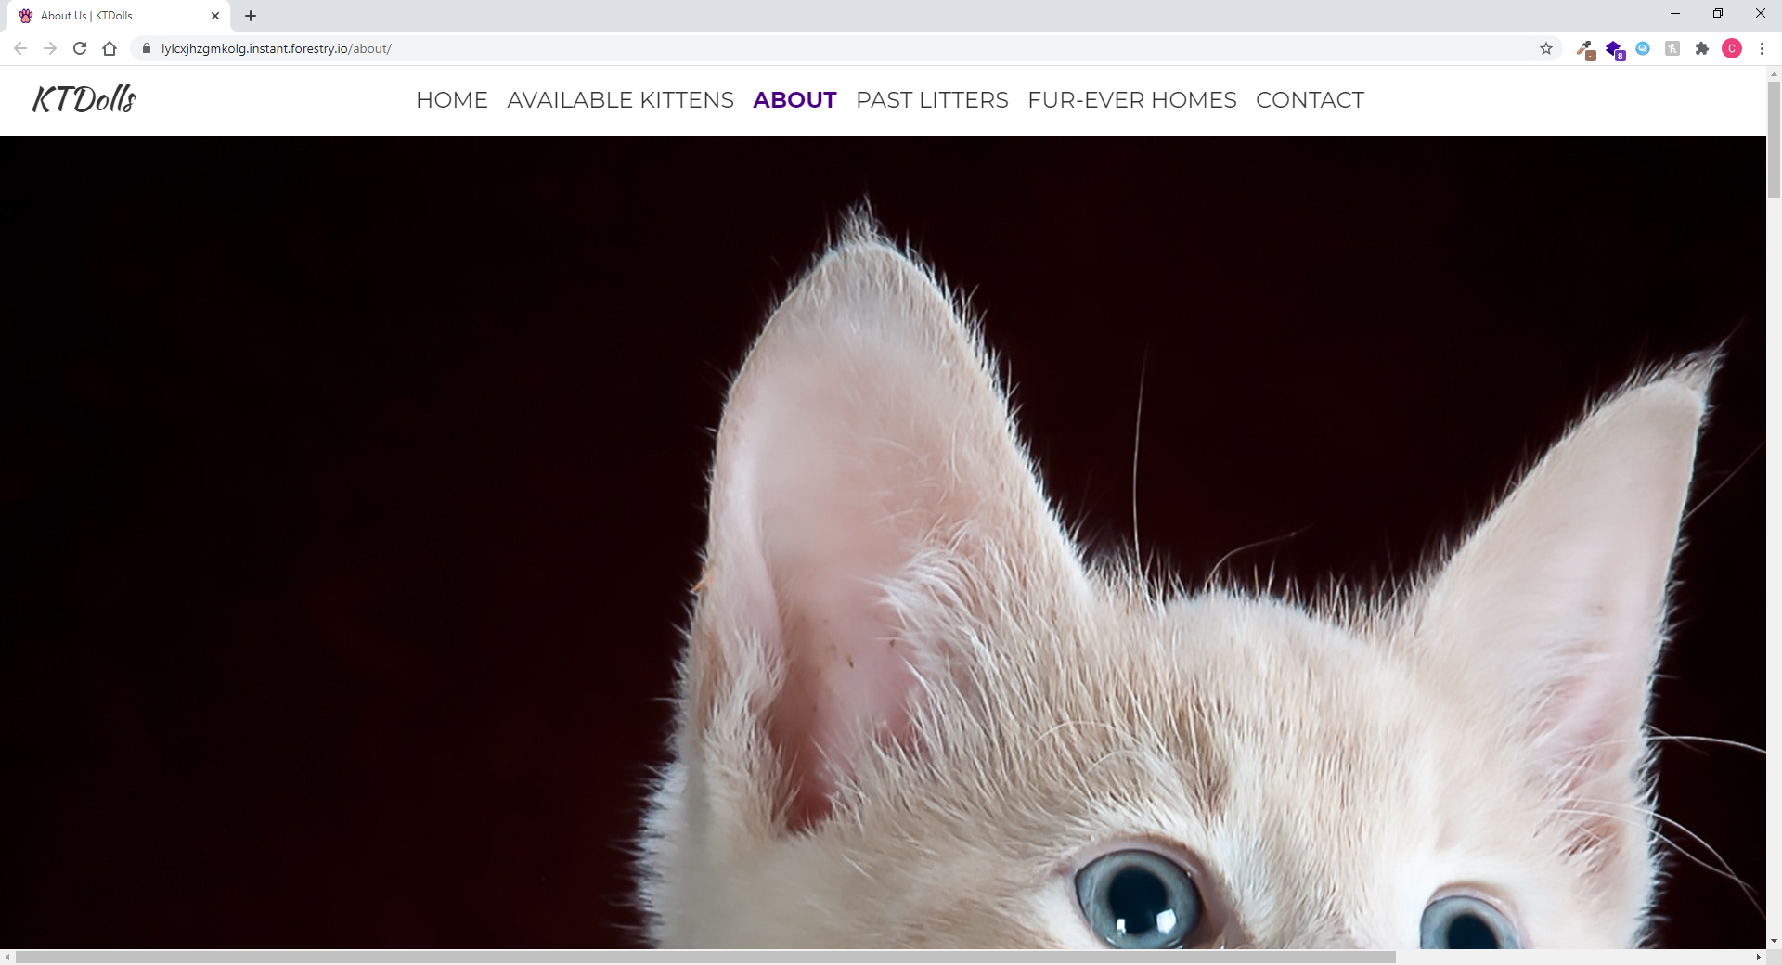

If this does happen, simply click “Unsaved changes” in the top left of the editor, and then “DISCARD CHANGES”.

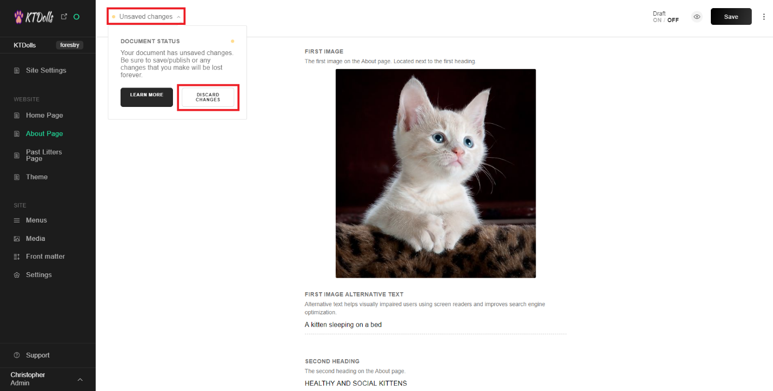

As you will see in the editor and preview site, the changes will have been reverted.

